**Portfolio Website**

**Introduction**

Hey there! I'm Rey Jhon Ñez, your guide to the world of graphic design and video editing. Whether you're a creative enthusiast or just curious about the artistic process, I'm here to help. So, let's embark on this journey together and uncover the magic behind crafting stunning visuals and captivating videos. Ready? Let's dive in!

**Stage 1: Inspiration Gathering for Graphic Design and Video Editing**

**Purpose**

Welcome to the exciting world of graphic design and video editing! This website is a celebration of our shared passion for these captivating art forms. My goal is to create a platform where creative enthusiasts can connect, explore, and immerse themselves in the world of stunning visuals and captivating videos. Join me on this journey as we discover the wonders of graphic design and video editing together.

**Objectives**

The goal is to build a captivating website that reflects my strong passion for graphic design and video editing. By collecting content, tutorials, project showcases, and insights, I hope to nurture a thriving online community of creative enthusiasts. This website will provide a space for fans to delve into the vibrant world of design and editing, uncovering new techniques, tools, and inspiration.

**Target Audience**

The goal is to create a visually captivating and user-friendly website for graphic design and video editing enthusiasts of all ages and backgrounds. Whether you're a seasoned professional or new to the field, this site will have something for everyone. From in-depth tutorials on popular techniques to showcasing hidden gems of creativity, the aim is to offer a diverse range of content that resonates with artists worldwide. So, grab your tools, get comfortable, and let's explore the exciting world of graphic design and video editing together.

**Stage 2: Crafting the Site Map**

I'm working on creating a site map for my portfolio website to showcase my profile and skills effectively. Drawing from my experiences, work, and expertise, I'm carefully structuring the website layout to ensure clarity and coherence. As part of this process, I've developed one images to visually depict the initial and final iterations of the site map.

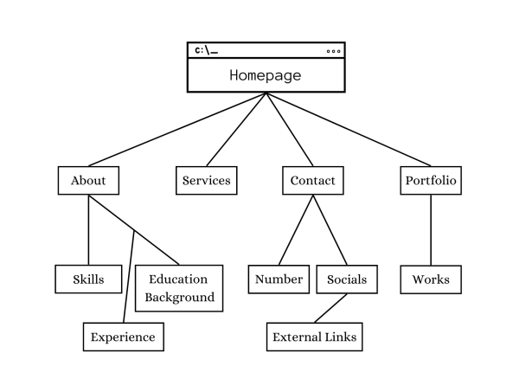I'll be establishing the foundational structure of the website, ensuring that key sections like Homepage, About, Services, Contact, and Portfolio are included. Each section will serve a specific purpose in conveying my professional identity and offerings to visitors.

**Stage 3: Developing the Wireframe**

I used the site map we had discussed as a starting point to create my wireframe. The site map helped me organize the content and layout of the website. With the main sections outlined, I structured the wireframe to ensure the portfolio and services were presented clearly and coherently. However, I expect to make some changes to the wireframe as the design process moves forward towards the final product.

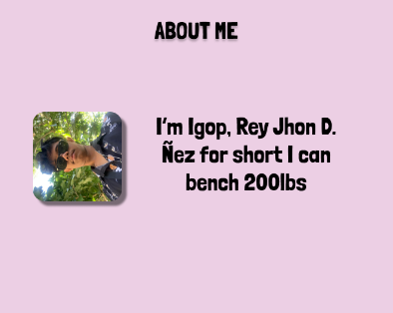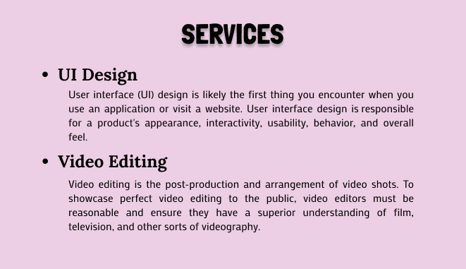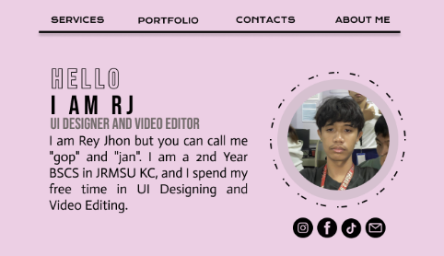

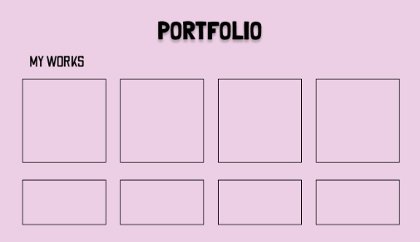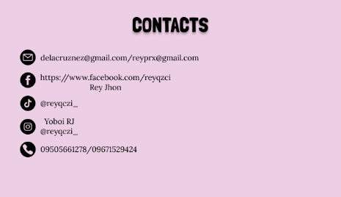

**Stage 4: Prototype Integration**

In this stage, I'll incorporate design components, content, and visuals into the prototype, preparing it for the subsequent coding phase. My main priority will be creating compelling portfolio content while ensuring smooth integration of images, fonts, and background colors across the website. This phase is a critical step in bringing the website to life, as I refine the visual presentation and user experience to align with our previously discussed goals. Stay tuned as we progress towards a polished and functional website in the upcoming development stages.

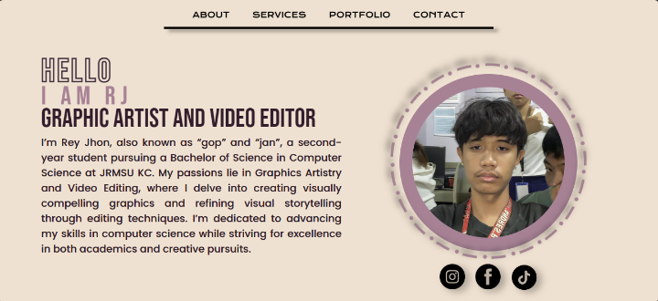

HOMEPAGE

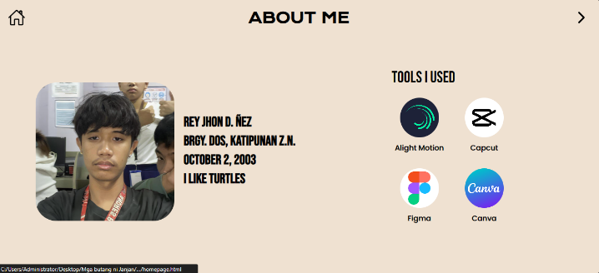

ABOUT ME

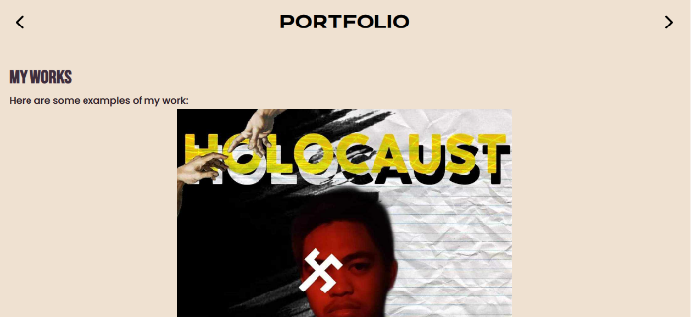

P PORTFOLIO

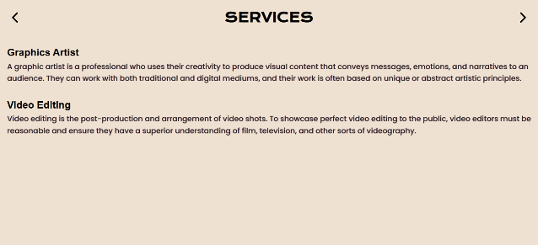

SERVICES

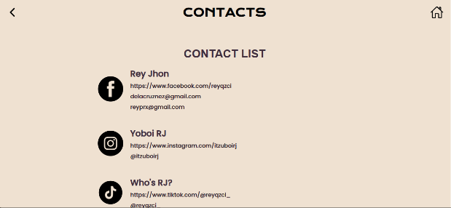

CONTACTS

**Stage 5: Coding the Graphic Design and Video Editing Portfolio Prototype**

In the coding stage, I'll take the design, content, and visuals created earlier and turn them into a working website prototype. This involves combining the design elements while ensuring the website functions properly and looks consistent. Although there may be some challenges and changes from the original layout, my main focus is capturing the spirit of the design. This stage is crucial for transforming the conceptual framework into a tangible, interactive platform that showcases the artistry and technical skills within the fields of graphic design and video editing.

**Stage 6: Testing and Deployment of the Graphic Design and Video Editing Portfolio Website**

In this stage, I thoroughly test the website's readability and compatibility on various devices. This crucial step guarantees a seamless experience for all users, whether they access the site from desktops, laptops, tablets, or smartphones. While I've made significant progress in adapting the layout for compatibility and ease of use, I anticipate encountering challenges during deployment. However, I remain dedicated to promptly addressing any issues to ensure a smooth launch and an optimal experience for all visitors. This meticulous testing ensures that the website not only looks great but also performs flawlessly, effectively showcasing creative works in the best possible way.

**Stage 7: Maintenance**

On stage 7 my graphic design and video editing portfolio website requires regular maintenance to keep it running smoothly. I'll regularly test the site to find and fix any problems, such as broken links, slow loading times, or issues with new browsers. I'll also carefully check that the website is easy to read and use on all devices, from desktops to smartphones. By staying on top of the website's upkeep, I can ensure it remains accessible and user-friendly, allowing creative enthusiasts to fully immerse themselves in our engaging online world. Regular maintenance is crucial for preserving the website's functionality and ensuring it continues to showcase creative works effectively.

REY JHON D. ÑEZ

BSCS-II-A